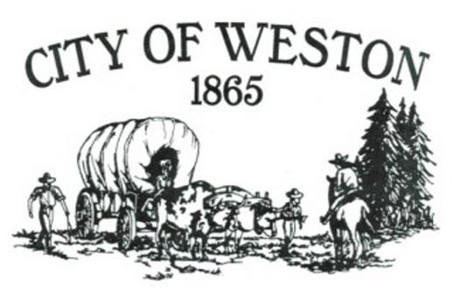
MAYOR’S CORNER – OCTOBER 2025

Dear Citizens,

I sent out letter last month about cleaning up your properties. There has been some compliance, but still, there are some folks who have not attempted to clean up anything. Just a friendly reminder that there can be a monetary fine for non-compliance. I don’t want to go that route, but I will if necessary.

Last weekend, our Assistant City Recorder was driving up Kirk Rd with her kids. They were almost to where it connects with Hwy 204 when they found a turtle, a BIG TURTLE, (later discovered to be a Sulcata tortoise) slowly walking alongside the road. They stopped and loaded it into the back of their SUV and brought it home, where she began calling several people to see who it may belong to. With a little help, she found out who owned it and returned it to its rightful owner on Janie Lane. Just goes to show you that even if you move slowly, you can go a long way at a steady pace.

A couple of reminders for this month:
- The 103rd Annual Umatilla County Potato Show will be on Saturday, October 25, 2025, at the Memorial Hall. Please stop by and show your support for all the vendors. Registration forms are available at City Hall, as well as other locations such as the post office.
- The next regular Council meeting will be held on Tuesday, October 21, 2025, at 6pm at Memorial Hall.

If anyone has concerns, suggestions, or just want to discuss things in the City, please don’t hesitate to stop by City Hall or give me a call at 541-263-1129.

Sincerely,

Mike Dowd – Mayor
City of Weston

