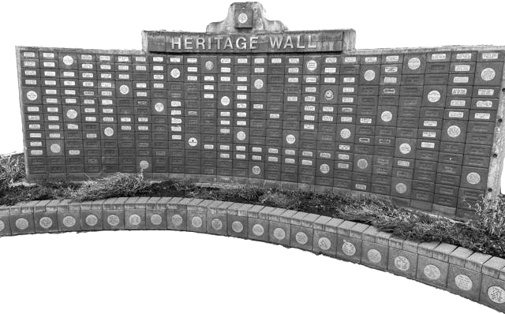
Weston Community
Development Commission
Weston, OR

WCDC August Meeting

The WCDC Meeting scheduled for August 25, 2025 was cancelled by the WCDC Chairperson, Dave Laufer. WCDC members were notified. Next meeting: September 29, 2025

