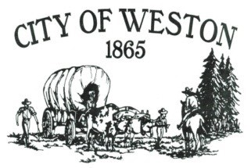

**MAYOR’S CORNER – JUNE 2025**

Dear Citizens,

I want to give a shoutout to the Public Works Department for the fantastic job they've done in sprucing up our town! They've painted stripes and curbs, updated the playground equipment, and even moved the park fence to create more parking space. Thank you for making our community look so great!

Just a quick update on the budget: it went before the budget committee on June 3, 2025, and the final approval by the City Council is happening on June 17. I also want to extend a special thanks to Duane Thul, our former Mayor, for his patience and guidance in helping me understand the budget process this year. And a huge thank you to Sierra Salvey, our City Recorder, for all her hard work in putting together the numbers and ensuring their accuracy.

This year's budget includes $15,000,000 in anticipated grant funds. While there might be some uncertainties regarding these funds due to the current governmental situation, we’ve included them as revenue and expenditures just in case we receive them.

I hope everyone has noticed that the recycling bins have been moved to the lot across the street from City Hall. We hope this makes it more convenient for everyone!

We are still facing an issue with yards that face the streets being filled with junk, garbage, and inoperable vehicles. Let's work together to take pride in our community and tidy these up, as they are considered code violations.

Apologies for the delay in this month’s newsletter! We've been busy with the budget, and our main copier is down (but good news—parts are on the way!).

We look forward to seeing you at Pioneer Days! Have a great June!

Sincerely,

Mike Dowd

Mayor of Weston