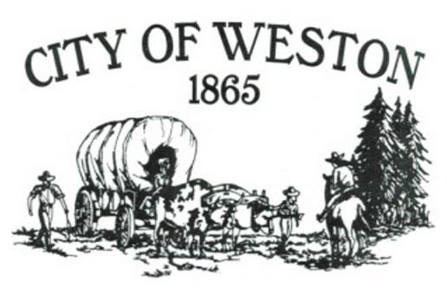
MAYOR’S CORNER – NOVEMBER 2025

Dear Citizens,

The City Recorder received a call from Humbert Refuse stating that people are putting household refuse into the cardboard bins. This is not only unacceptable, but it will also cause us to lose the privilege of having recycle bins in Weston. Please stop!!!

Public Works began crack-sealing Water Street on October 14th. The project continued for several days and was completed on October 17th.

Public Works is also continuing to install smart water meters as time allows. They have been busy winterizing all the city buildings and grounds. If you see them, please let them know you appreciate them.

A couple of reminders for this month:
- If you are building a yard fence, a structure, or anything that may need planning approval, please stop by City Hall or the Planning Office (located at the old City Shop office by the park) and get proper applications. Please do not start any project without proper approval.
- The leaves are beginning to fall. Please do not rake or blow your leaves into the street or onto the creek bank. It is not Public Works’ job to pick up your leaves. Please dispose of them appropriately.
- City Hall, the Library, and Public Works will be closed on Tuesday, November 11th for Veteran’s Day and Thursday, November 27th for Thanksgiving Day.
- The next regular Council meeting will be held on Tuesday, November 18, 2025, at 6pm at Memorial Hall.

A big thank-you to Sierra and Danielle, who every day make my job as Mayor easier. They keep me grounded and focused.
If any citizen has concerns, suggestions, or just want to discuss things in the City, please don’t hesitate to stop by City Hall or give me a call at 541-263-1129.

Sincerely,

Mike Dowd – Mayor
City of Weston

