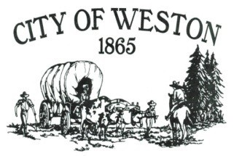

**MAYOR’S CORNER – MAY 2025**

Dear Citizens:

Mark your calendars for Saturday, May 3rd! Join us for the City of Weston/Humbert Refuse annual free dump day and City Cleanup. Together, we can create a cleaner, more beautiful community in which we can all take pride. Your participation truly makes a difference!

The city is beginning to look better, but we still have issues with unlicensed and junk vehicles parked in the city right-of-way, trailers in the right-of-way, and backyards filled with overflowing garbage bags. I urge everyone to make a dedicated effort to clean these up before Pioneer Days.

At the April council meeting, we approved the Pioneer Association's annual picnic and parade scheduled for June 6th and 7th.

The council also approved the purchase of a new server computer for City Hall and a new surge protector for Public Works at the lagoon site.

We still have several outstanding utility bills. The settlement of these is crucial for the smooth functioning of our city services. Please visit City Hall to arrange payment with our City Recorder to catch up on these bills. Your commitment to this matter is greatly appreciated.

Thank you to WCDC and Public Works for the beautiful flowers on Main Street. Your efforts have truly enhanced the beauty of our city.

Please note that City Hall, Public Works, and the Library will be closed **on Monday, May 26th**, in observance of Memorial Day. The next Council Meeting will be held **on Tuesday, May 20th**.

Have a great month!

Sincerely,

Mike Dowd

Mayor of Weston