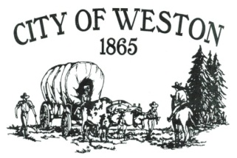

114 East Main PO Box 579 Weston, OR 97886

Tel* (541) 566-3313 *Fax (541) 566-2792

Sierra Salvey, City Recorder

Recorder@cityofwestonoregon.com

“This institution is an equal opportunity provider and employer”

***APPLICATION FOR BUSINESS REGISTRATION***

**Fee : $45.00**

**Today’s Date:_______________________ Year of License: 2025-2026**

**Business Name:________________________________________________________________**

**Type of Business:______________________________________________________________**

**Business Address: PO Box___________, Street_____________________, Weston, OR 97886**

**Business Telephone:_____________________ Other:________________________________**

**Owner’s Name if different than applicant:_________________________________________**

**Owner’s Personal Address:______________________________________________________**

**Applicant’s # years with Weston Business:_________________________________________**

**Service and/or Merchandise Provided:**_____________________________________________________________________

**State/Federal Business Registration#______________________________________________**

**Applicant’s Printed name & Position Held:________________________________________**

**Applicant’ Signature____________________________________________________________**

**Approved__________________Denied______________________Date:__________________**