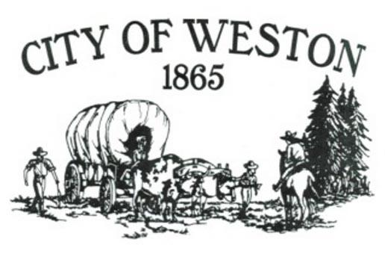
114 E Main St – P.O. Box 579 – Weston, OR 97886
541-566-3313 * 541-566-2792 Fax
www.CityofWestonOregon.com

City Council Work Session
July 3, 2025

Those present were Mayor Dowd, Councilors Greg Phillips, Bill Boyd, Carol Kirk and Darla Joy. Also present was Annie Boyd and just before the meeting ended, Erick Bengel arrived from the Union Bulletin.

We discussed trash in yards, broken and discarded vehicles, and delinquent water bills.

It was discussed to write letters to the public, a blanket letter stating what the citizens of Weston want done in their community, to make it a better place to live. Along with this letter, it will site the statutes and fee schedule for non-compliance.

With the overdue utilities, we discussed writing the overdue patron a letter giving them thirty (30) days to come into City Hall and make a written payment plan to follow. The first (1st) month they do not adhere to the plan the water will be shut off.

It was also discussed to form a committee of four (4) people to observe and monitor progress on each of these properties.

Meeting adjourned at 5:40 P.M.

